Real Estate EDA

Edris Safari

2/27/2020

# Final Project

The purpose of this project is to use techniques learned in this class to exercise exploratory data analysis on a given data set, The dataset chosen for this project are:

* properties_2016.csv
* transactions_2016.csv

properties dataset contins the information about individual homes that were sold in 2016. The transaction dataset has the transaction date when the house was sold and the log error from the sales price estimated by zillow(zestimate).

For more details about the progression and assembly of this project, please refer to the accompanying document ***DSC520_FinalProject-EdrisSafari-week_12.pdf***

***NOTE*** The properties data file was far too large and took a lot of time to process, so we reduced its size by to 20, and 30 percent respectively. After tests, we submit this project with the smaller size of 20 percent.

properties <- read.csv(“zillow-prize-1/properties_2016.csv”) nrow(properties) # almost 3 million records sample_20 <- properties[sample(nrow(properties), nrow(properties)*.20),] sample_30 <- properties[sample(nrow(properties), nrow(properties)*.30),] nrow(sample_20) nrow(sample_30) write.csv(sample_20,“zillow-prize-1/properties_2016_sample_20.csv”) write.csv(sample_30,“zillow-prize-1/properties_2016_sample_30.csv”)

properties <- read.csv(“zillow-prize-1/properties_2016_sample_20.csv”) nrow(properties)

Also note that the output to pdf is not supported, and the absolute log error map at the end of this file does not output to word document, so we copied it from HTML file, and saved the word document as pdf for submission.

# Data Preparation

## Features with percentage of missing values

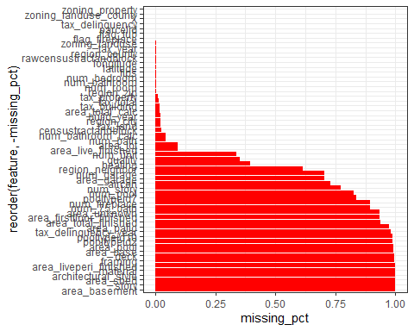

## Selected features

X, parcelid, aircon, num_bathroom, num_bedroom, quality, num_bathroom_calc, area_total_calc, area_live_finished, fips, num_bath, num_garage, area_garage, flag_tub, heating, latitude, longitude, area_lot, zoning_landuse_county, zoning_landuse, zoning_property, rawcensustractandblock, region_city, region_county, region_neighbor, region_zip, num_room, num_unit, build_year, flag_fireplace, tax_building, tax_total, tax_year, tax_land, tax_property, tax_delinquency, censustractandblock

# Data set info

## Summary of transactions data set

## parcelid logerror date   
## Min. : 10711738 Min. :-4.60500 2016-07-29: 910   
## 1st Qu.: 11559500 1st Qu.:-0.02530 2016-04-29: 902   
## Median : 12547337 Median : 0.00600 2016-09-30: 894   
## Mean : 12984656 Mean : 0.01146 2016-06-30: 874   
## 3rd Qu.: 14227552 3rd Qu.: 0.03920 2016-05-27: 863   
## Max. :162960842 Max. : 4.73700 2016-08-31: 737   
## (Other) :85095

## head of transactions data set

## parcelid logerror date  
## 1 11016594 0.0276 2016-01-01  
## 2 14366692 -0.1684 2016-01-01  
## 3 12098116 -0.0040 2016-01-01  
## 4 12643413 0.0218 2016-01-02  
## 5 14432541 -0.0050 2016-01-02  
## 6 11509835 -0.2705 2016-01-02

## head of properties data set

## X parcelid aircon architectural_style area_basement num_bathroom  
## 1 2342182 12484350 1 NA NA 4  
## 2 541880 12181530 NA NA NA 1  
## 3 1617969 14222705 NA NA NA 0  
## 4 1729095 11467838 NA NA NA 2  
## 5 84189 13015665 NA NA NA 1  
## 6 1570086 12633721 NA NA NA 4  
## num_bedroom framing quality num_bathroom_calc deck area_firstfloor_finished  
## 1 6 NA 4 4 NA NA  
## 2 2 NA 7 1 NA NA  
## 3 0 NA NA NA NA NA  
## 4 3 NA 7 2 NA NA  
## 5 2 NA 7 1 NA NA  
## 6 6 NA 7 4 NA NA  
## area_total_calc area_live_finished area_liveperi_finished area_total_finished  
## 1 3315 3315 NA NA  
## 2 1088 1088 NA NA  
## 3 4231 NA NA NA  
## 4 1327 1327 NA NA  
## 5 976 976 NA NA  
## 6 3030 NA NA 3030  
## area_unknown area_base fips num_fireplace num_bath num_garage area_garage  
## 1 NA NA 6037 NA 4 NA NA  
## 2 NA NA 6037 NA 1 NA NA  
## 3 NA 4231 6059 NA NA 0 0  
## 4 NA NA 6037 NA 2 NA NA  
## 5 NA NA 6037 NA 1 NA NA  
## 6 NA NA 6037 NA 4 NA NA  
## flag_tub heating latitude longitude area_lot num_pool area_pool pooltypeid10  
## 1 2 33852329 -118125098 6548 NA NA NA  
## 2 NA 33986932 -118297793 6008 NA NA NA  
## 3 NA 33819470 -117832954 9118 NA NA NA  
## 4 7 33958756 -118398254 5145 NA NA NA  
## 5 7 34138321 -117908275 7000 NA NA NA  
## 6 NA 33782587 -118251435 7000 NA NA NA  
## pooltypeid2 pooltypeid7 zoning_landuse_county zoning_landuse zoning_property  
## 1 NA NA 0100 261 LKR1YY  
## 2 NA NA 0100 261 LAR2  
## 3 NA NA 96 248   
## 4 NA NA 0100 261 LAR1  
## 5 NA NA 0100 261 AZR1C*  
## 6 NA NA 0200 246 LAR2  
## rawcensustractandblock region_city region_county region_neighbor region_zip  
## 1 60375708 12292 3101 NA 96212  
## 2 60372372 12447 3101 118208 96025  
## 3 60590758 33252 1286 NA 97063  
## 4 60372780 12447 3101 7877 96026  
## 5 60374006 37015 3101 NA 96464  
## 6 60372947 12447 3101 48516 96228  
## num_room story num_75_bath material num_unit area_patio area_shed build_year  
## 1 0 NA NA NA 1 NA NA 1950  
## 2 0 NA NA NA 1 NA NA 1940  
## 3 0 NA NA NA 4 NA NA 1973  
## 4 0 NA NA NA 1 NA NA 1944  
## 5 0 NA NA NA 1 NA NA 1921  
## 6 0 NA NA NA 2 NA NA 1921  
## num_story flag_fireplace tax_building tax_total tax_year tax_land  
## 1 NA 255065 277073 2015 22008  
## 2 NA 22500 172568 2015 150068  
## 3 2 212125 353550 2015 141425  
## 4 NA 97880 370695 2015 272815  
## 5 NA 94231 262698 2015 168467  
## 6 NA 225985 242687 2015 16702  
## tax_property tax_delinquency tax_delinquency_year censustractandblock  
## 1 3766.44 NA 6.037571e+13  
## 2 2186.02 NA 6.037237e+13  
## 3 4655.98 NA 6.059076e+13  
## 4 4610.51 NA 6.037278e+13  
## 5 3303.92 NA 6.037401e+13  
## 6 3144.99 NA 6.037295e+13

## Column names

### properties

X, parcelid, aircon, architectural_style, area_basement, num_bathroom, num_bedroom, framing, quality, num_bathroom_calc, deck, area_firstfloor_finished, area_total_calc, area_live_finished, area_liveperi_finished, area_total_finished, area_unknown, area_base, fips, num_fireplace, num_bath, num_garage, area_garage, flag_tub, heating, latitude, longitude, area_lot, num_pool, area_pool, pooltypeid10, pooltypeid2, pooltypeid7, zoning_landuse_county, zoning_landuse, zoning_property, rawcensustractandblock, region_city, region_county, region_neighbor, region_zip, num_room, story, num_75_bath, material, num_unit, area_patio, area_shed, build_year, num_story, flag_fireplace, tax_building, tax_total, tax_year, tax_land, tax_property, tax_delinquency, tax_delinquency_year, censustractandblock

### transactions

parcelid, logerror, date

## statistics of logerror in transactions

* Mean : 0.0114572
* median : 0.006
* std : ’ 0.1610788
* Max: 4.737
* Min: -4.605

# Data exploration

## Scatter plot of logerror

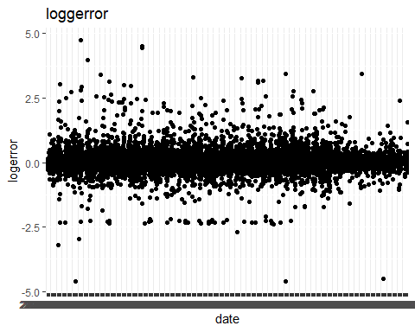

## histogram of logerror

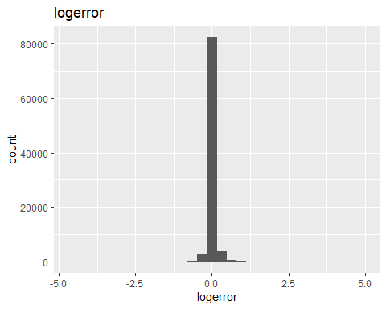

## histogram of logerror binned

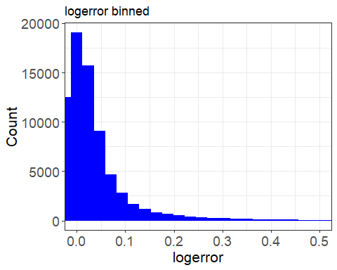

## parcelid logerror date year_month abs_logerror  
## 1 11016594 0.0276 2016-01-01 2016-01-01 0.0276  
## 2 14366692 -0.1684 2016-01-01 2016-01-01 0.1684  
## 3 12098116 -0.0040 2016-01-01 2016-01-01 0.0040  
## 4 12643413 0.0218 2016-01-02 2016-01-01 0.0218  
## 5 14432541 -0.0050 2016-01-02 2016-01-01 0.0050  
## 6 11509835 -0.2705 2016-01-02 2016-01-01 0.2705

## Scatter plot of abs_loggerror

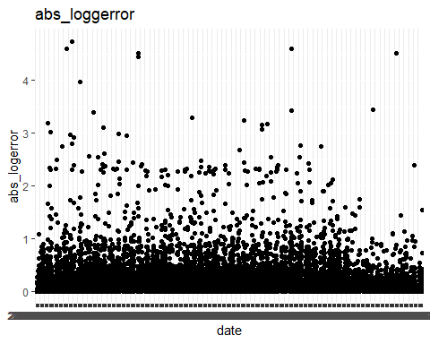

## parcelid logerror date year_month abs_logerror  
## 1 11016594 0.0276 2016-01-01 2016-01-01 0.0276  
## 2 14366692 -0.1684 2016-01-01 2016-01-01 0.1684  
## 3 12098116 -0.0040 2016-01-01 2016-01-01 0.0040  
## 4 12643413 0.0218 2016-01-02 2016-01-01 0.0218  
## 5 14432541 -0.0050 2016-01-02 2016-01-01 0.0050  
## 6 11509835 -0.2705 2016-01-02 2016-01-01 0.2705

## Histogram of abs_loggerror

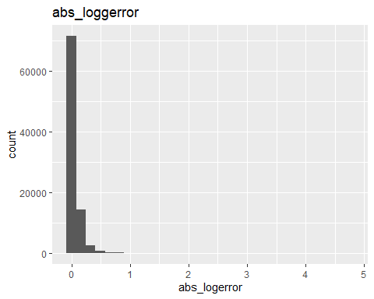

## Histogram of abs_loggerror binned

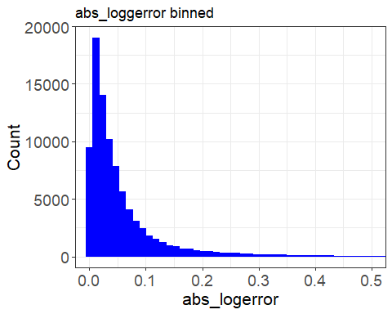

## geom_bar: na.rm = FALSE  
## stat_bin: binwidth = NULL, bins = NULL, na.rm = FALSE, pad = FALSE  
## position_stack

## graph of abs_logerror groupped by month of year

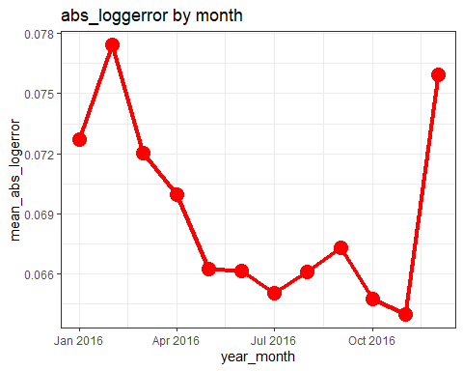

## graph of abs_logerror within strandard deviation

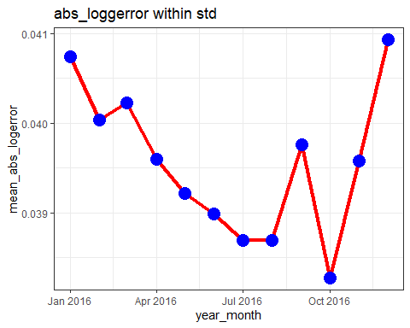

## Correlations

## num_bathroom num_bedroom num_bathroom_calc num_bath num_garage num_room  
## 1 NA NA NA NA NA NA  
## 2 NA NA NA NA NA NA  
## 3 3 2 3 3 NA 0  
## 4 NA NA NA NA NA NA  
## 5 NA NA NA NA NA NA  
## 6 4 4 4 4 NA 0  
## num_unit logerror abs_logerror  
## 1 NA 0.0276 0.0276  
## 2 NA -0.1684 0.1684  
## 3 1 -0.0040 0.0040  
## 4 NA 0.0218 0.0218  
## 5 NA -0.0050 0.0050  
## 6 1 -0.2705 0.2705

### correlation using ggpairs using a subset of data(~10%)

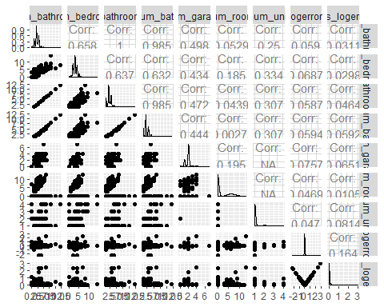

### correlation using corrplot

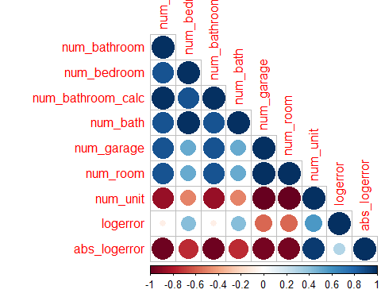

## parcelid logerror date year_month abs_logerror percentile  
## 1 11016594 0.0276 2016-01-01 2016-01-01 0.0276 3  
## 2 14366692 -0.1684 2016-01-01 2016-01-01 0.1684 5  
## 3 12098116 -0.0040 2016-01-01 2016-01-01 0.0040 1  
## 4 12643413 0.0218 2016-01-02 2016-01-01 0.0218 3  
## 5 14432541 -0.0050 2016-01-02 2016-01-01 0.0050 1  
## 6 11509835 -0.2705 2016-01-02 2016-01-01 0.2705 5

### Density plot shows density of worst predicitons is lower in lower latitudes , but higher in median lattitude and lowwer around and above 34400000.

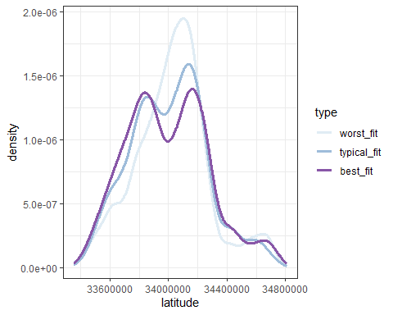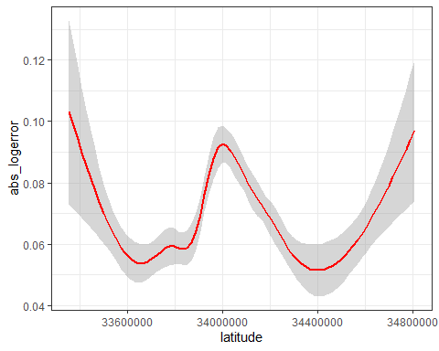

### denisity of longitude. Worst predictions are in the -118500000 and -118000000

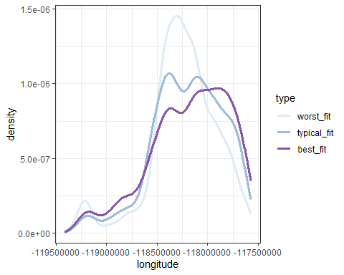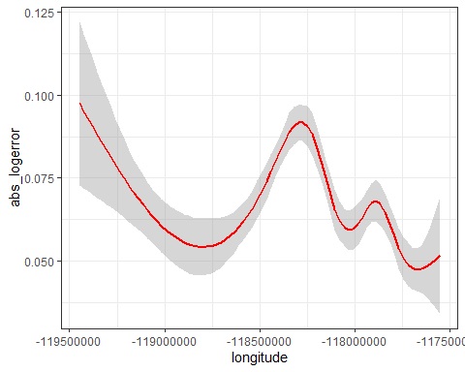

### area_total_finished

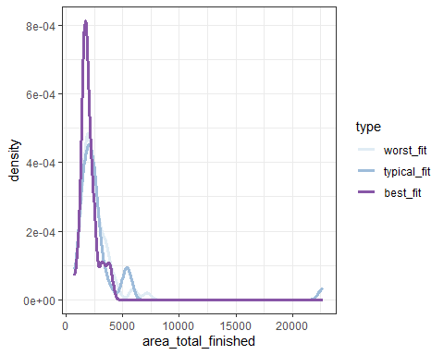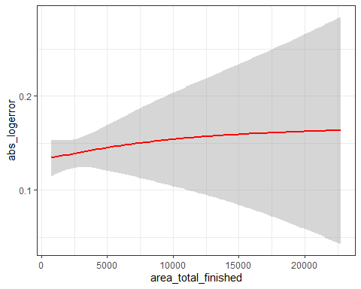

### num_room

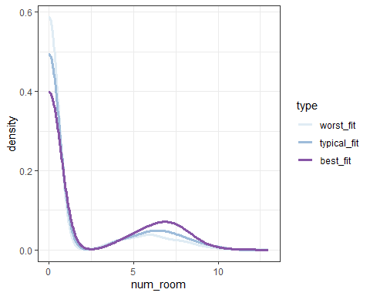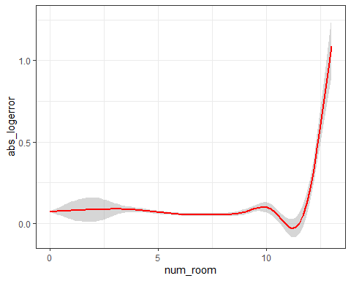

### maps based on a sampling of 10000 properties

#### Map of Los Angels county

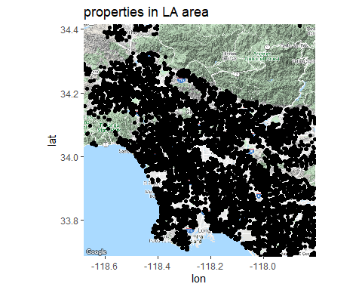

#### Map of Orange County

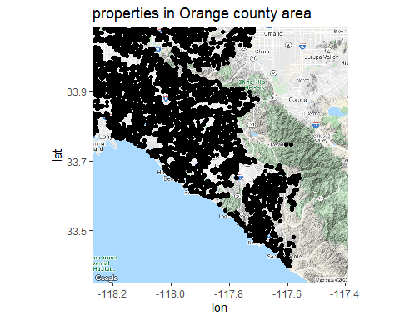

#### Map of Ventura County

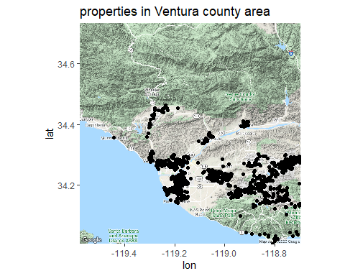

### Absolute log error based on location

